**Evaluation and report**

**About:**

Our chatbot is themed off of Tom Riddle’s Diary from Harry Potter and the chamber of secrets. It can respond like Tom Riddle, Answer simple questions about the Harry Potter universe, and Remember simple things about each user. As this is a Chatbot based on a sentient diary, we added a website portion (the preferred way to interface with the chatbot) which can be accessed by running “flask run” while within the directory with app.py This makes available a diary styled webpage where you can type and get a response just like in the movie. This must be done on a computer not a phone or mobile device

**System Description:**

Our Tom Riddle chatbot combines a number of techniques learned in this class. When you first interface with the chatbot, your statement is first processed by the NLTK chatbot util library. These parsings will first weed out any knowledge base questions and any user info questions. For instance if the user says “Who is dumbledoooore” the nltk code will parce that and then return the summary of the harry potter wikia page for Dumbledore. Notice how you don't have to spell the name correctly. We used a fuzzy search algorithm to essentially do a spell check on the user input. If you tell the bot your house by saying, “My house is gryffendoire” the bot will also autocorrect it. If you spell it so wrong that the fuzzy search is not confident in its correction, the Tom Riddle bot will insult you. If your statement meets none of the criteria above, the wildcard case will send what you wrote to a library called chatterbot. This works much like Cleverbot as it learns from previous interactions. We pretrained the bot on lines from the movies and books as well as just sample interactions we felt might happen with the bot. It isn't perfect at all, but it is better than the strict command based system NLTK is based off of. Sometimes it gets confused and starts responding with statements that were meant to be asked of it by the user.

The knowledge base was a whole other can of worms. We started by making a recursive web crawler that started at the Harry Potter page on wikia(fandom) that would pick 3 random links on a page and visit them up to a depth of 6. This resulted in 3000+ links visited. Each link was then summarized using a term frequency summarizer to pick out only the most important sentences. This was done to avoid unnecessary information.

The website interface is handled through flask and uses a simple REST api to talk to the chatbot. The website generates and saves your uuidv4 userID and uses that to retrieve saved information with each request. The website also uses CSS animations and Javascript to animate the words to make them look like the movie.

**Logic Diagram:**

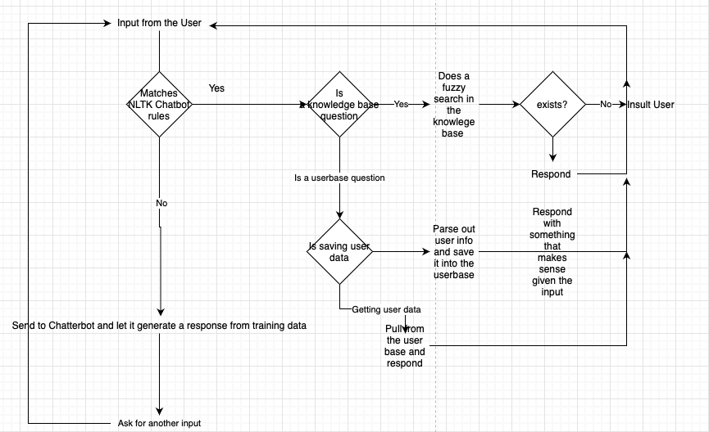

**Knowledgebase Appendix example**:

When in the JSON format the knowledge base is 16,766 lines long all from pages on the Harry Potter Wikia. Below is an excerpt from the knowledgebase

"harry potter": {

"link": "https://harrypotter.fandom.com/wiki/File:Harry_Potter_movies_hbp_promostills_6.jpg",

"summary": "The only child and son of James and Lily Potter (n\u00e9e Evans), Harry's birth was overshadowed by a prophecy, naming either himself or Neville Longbottom as the one with the power to vanquish Lord Voldemort. After half of the prophecy was reported to Voldemort, courtesy of Severus Snape, Harry was chosen as the target due to his many similarities with the Dark Lord. During this attempt, he murdered Harry's parents as they tried to protect him, but this unsuccessful attempt to kill Harry led to Voldemort's first downfall. This downfall marked the end of the First Wizarding War, and to Harry henceforth being known as \"The Boy Who Lived\", as he was the only known survivor of the Killing Curse. One consequence of Lily's loving sacrifice was that her orphaned son had to be raised by her only remaining blood relative, his Muggle aunt Petunia Dursley. While in her care, he would be protected from Lord Voldemort due to the Bond of Blood charm Albus Dumbledore placed upon him. This powerful charm would protect him until he became of age, or no longer called his aunt's house home. Due to Petunia's resentment of her sister and her magic gifts, Harry grew up abused and neglected. The Sorting Hat hat told Harry that he would do well in Slytherin House, but Harry pleaded 'not Slytherin' and the Hat heeded this plea, instead sorting the young wizard into Gryffindor House."

},

"diagon alley": {

"link": "https://harrypotter.fandom.com/wiki/Diagon_Alley",

"summary": "Diagon Alley was a cobblestoned wizarding alley and shopping area located in London, England behind a pub called the Leaky Cauldron. The Leaky Cauldron was present long before Charing Cross Road was even planned in the nineteenth century; its true address was number one, Diagon Alley, and it was believed to have been built some time in the early 1500s, along with the rest of the wizarding street. It was a popular historical theory that the second oldest building in Diagon Alley was Gringotts Wizarding Bank and that the other shops grew up around it. The then Minister for Magic, Ulick Gamp, agreed to give the landlord of the day present at the Leaky Cauldron responsibility for letting people into Diagon Alley from his back yard. In 1926, one of the shops in Diagon Alley was burgled with the help of a Four-Headed Bird. Harry Potter's first visit to Diagon Alley with Rubeus Hagrid marked his re-introduction to the wizarding world. Harry's first stop was Gringotts Wizarding Bank, where he encountered Goblins for the first time."

},

"quidditch": {

"link": "https://harrypotter.fandom.com/wiki/File:Blagging.jpg",

"summary": "It was the most popular game and most well-known game among wizards and witches, and, according to Rubeus Hagrid, the equivalent to Muggles' passion for football (Soccer). Some games could go on for many days if the Snitch was not caught (the record, according to Quidditch Through the Ages, was six months, although no one caught the Snitch.) While Quidditch was the first (and so far, only) broomstick-based game to attain near-worldwide popularity amongst the wizarding people, it was certainly not the first broomstick game. All of these archaic broom games were popular in localised areas, but none had the vast appeal that Quidditch did. The beauty of Quidditch was that it took the best aspects of all its predecessors, added its own unique twists, and ended up as a game that would remain popular with the masses for centuries. The main ancient games that provided some inspiration for Quidditch were:\nA game by the name of Stichstock originated in Germany and consisted of a single wizard acting as a guardian or goalkeeper, trying to protect an inflated dragon bladder. An Irish game by the name of Aingingein required broomstick-mounted players to fly through a number of burning barrels set in the air, whilst all the time clutching a ball with one hand."

},

**User Appendix example:**

Each attribute is optional and will be asked if the chatbot needs the info

{

"af622abe-78a3-49c7-977e-616168d5e185": {

"name": "Joseph Hassell",

"house": "Ravenclaw"

},

"4jk5hggh-fggg-kg76-33d4-064612321fsg": {

"name": "Ace",

"character": "Harry Potter",

"house": "Gryffindor"

}

}

**Sample Dialog interaction:**

You: Hello

Bot: Hello, What is your name?

You: I am Ace, nice to meet you.

Bot: Hello Ace, it is nice to meet you as well.

---------

You: Do you know my name?

Bot: You are Ace

Or

Bot: You haven’t told me yet.

You: Do you know my house?

Bot: of course i remember you, you are a true believer. Your house in Slytherin.

Or

Bot: Ohh you are from Gryffindor, you are not worth my time.

Or

Bot: You haven’t told me yet.

---------

You: "Are you a ghost?",

Bot: "A memory?. Preserved in a diary for fifty years.",

You: "Give me my wand.",

Bot: "You wont be needing it",

You: "Are you Voldemort?",

Bot: "Voldemort is my past, present and future.",

You: "Who is the greatest sorcerer in the world?",

Bot: "Me obviously",

You: "Could it be Harry?"

Bot: "Not a chance"

------------

You: "Were you part of any Clubs?",

Bot: "Yes, thanks you asking. I was a member of Slug Club.",

You: "What is a Slug CLub?",

Bot: "A club made by Professor Slughorn, exclusive to only brilliant and promising students.",

You:"How old are you?",

Bot: "Older than you for sure",

You: "Do you know Ralph Fiennes?",

Bot: "Ahh yes i do, lovely fellow.",

-------------

You: "What were some your achievements at Hogwarts ",

Bot: "Finally something worth talking about, i was the head boy during my time.",

# "Did you ever receive any medals?",

Bot: "I was awarded with the medal of magical merit",

# "Who is the boy who lived?",

Bot: harry potter is his name.

You: "What are some of the cool things you can do",

Bot: "Everything that i do is cool but to name a few, i can control all animals and fly without the need of a broom.",

You: "Who is the other silent killer?",

Bot: "Dumbledore, he isnt as great as everyone thinks he is.",

**Strength And Weakness of Our ChatterBot**

**Question1)**

On a scale from 1-5 (5 being the best), How natural do you find the conversations with the chatbot  
Response: **Rating: 3/5** The response is relatively natural. When you ask a question that is unrelated to the genre of the chat bot (Harry Potter), the chat bot does not make a great response. But when you ask harry potter esque questions, the chat bot does a great job in answering your questions in a fun way.

**Question2**)

How sufficient did you find the chatbot’s general knowledge about the Harry Potter universe to be? (1 being terrible, 5 being amazing)

Response: **Rating 5/5.** When asking Harry Potter related questions, it does a great job answering the questions accurately.

**Question3**)

Did you find the website / design of the diary to be appealing? What is something you think can be improved upon? What did you dislike about talking to the program?

It was an interesting website design. There are not a lot of buttons or distractions on the website but there should be a pop up with directions when you click on the site. There is not any guide on how to use it. ¾

**The Consensus:**

This chatbot is flawed in a few ways. The web interface is somewhat buggy, The chatterbot responses are dull and sometimes make no sense, and the knowledge base, while expansive, may still not answer every question as it lacks context. HOWEVER, it is our belief that these flaws could be fixed with time. The chatterbot issue especially could be fixed if we had more training data. The other issue with chatterbot is that there is no distinction between what the chatbot should respond with and what the user said. This is by design of course as it allows the chatbot to learn as you use it, but when you have a small dataset to train it on it can get confused. For instance it will sometimes respond with “Are you voldemort” when the chatbot itself is supposed to represent Voldermort (Tom Riddle). I think however this chatbot is strong in how it is able to